2019.2.14

**Inbound Remittance Process**

**Objective**

1. Receiver Should Automatically receive Money in his bank account once the receiver KYC is completed and after CS team approves his ID

(수신인은 KYC(신원확인)가 완료되고, CS팀이 수신인 ID를 승인하면 수신인 계좌에 자동으로 돈을 받을 수 있다.)

1. Receiver should be required to do KYC only first time

(수신인은 KYC(신원확인)를 한번 실행한다.)

1. Receiver should have GME USer ID and password when he completes receivers’ KYC

(수신인은 KYC(신원확인)를 실행할 때, 회원가입한 ID와 패스워드를 가지고 있어야 한다.)

1. If Receiver already has registered with GME as a sender then he shouldn’t have to do receivers KYC Again.

(수신인이 이미 GME에 발신인으로 등록했다면, 수신인 등록에 필요한 KYC(신원확인)를 하지 않아도 된다.)

1. Receiver should be able to Send Money after he completes incomplete field while he sends the money.

(수신인은 송금을 하는 동안 불완전한 필드를 입력한후, 송금을 할 수 있어야 한다.)

1. There should be no duplicate customers ( Receiver and sender should not be duplicate)

(송금인과 수신인은 중복되지 않아야 한다.)

**Basic Process**

Ria/Xpress Money System

GME Core System

If Receiver already not registered send SMS/Email to Receiver



Unique link

gmeremit.com/receiverkyc/Xbycgh20

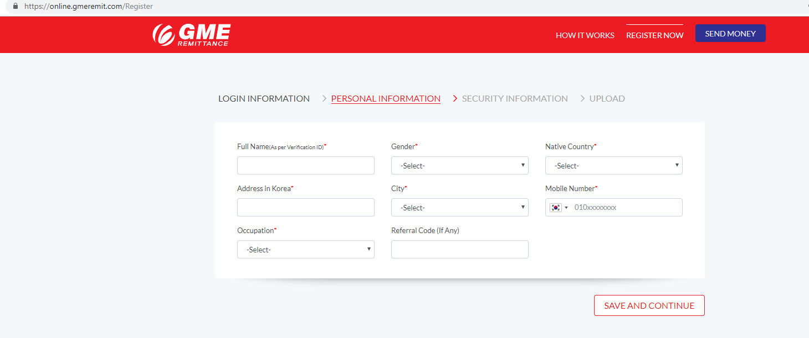

Receiver will key in his details* and upload photo of His ID

Penny Test and Real name verification from KJ Bank

Photo ID Verification by Nepal CS

After Successful verification , Money will be deposited

*Landing Page: Data Field for Receiver KYC

1. Full Name
2. Gender
3. Nationality
4. DOB
5. City
6. Mobile Number
7. Email Address
8. Bank Name
9. Bank Account No.
10. ID Type
11. ID No.

Page 2: Photo ID Required

1. Alien Card front and Back